Holiday camp “ Mazhathullikal”-2016
As a relief from the burning sun rays of summer holidays the rain drops showered on earth to make it cool and happier to the whole living beings. In the same auspicious occasion Namaste also decided to cool and refresh the minds of Namaste students through the programme” Mazhathullikal “to make them enjoy, to aware and to give lights to their brain through the funny, knowledgeable and provoking games. Expert personalities on the subject matter and also the full time Namaste facilitators lead the students in a very effective way to make them enjoyable and knowledgeable.
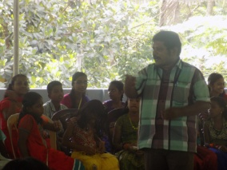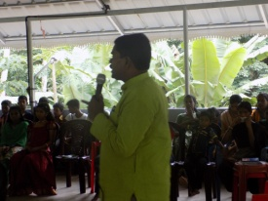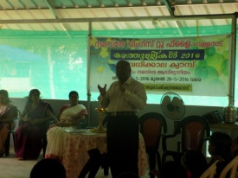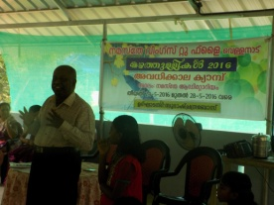

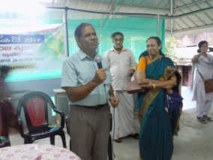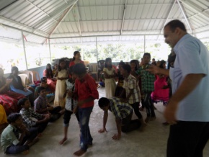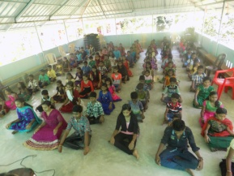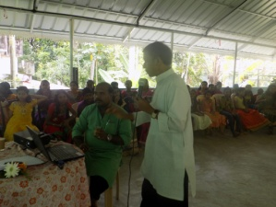
The camp was inaugurated by DR. Subhash Chandra Bose( Director, DCPU) and he gave a lecture about t Water and the importance of water Conservation and various methods of water sheds. The Camp description, Ice breaking and the mind refreshment section was conducted by Mr. Chandra Babu (Namaste treasurer) and the addressing speech by Mr. Vellanad Ramachandran. Other great personalities were Adv. Saju on environment Protection and also he provoked children to “Dream”. DR Nithya. Discussed the problems of adolescents and gave a counselling and mind refreshments, Mrs. Sindhu on Personality Development class. Fr. Dennis Mannoor discussed about Healthy Food and also the environment protection by avoiding plastics and Mr. Emmanuel Sylas (representative from childline) discussed very informative speech about our lakes. Yoga, spontaneous presentations and Group plays were conducted in the camp. The camp ended with Malayalam Poetry sections and folk songs by S.T Sajan and a valedictory function presided by the President of Namaste , distributed Prizes to those who performed well in the camp . Miss Reshma was the Best reporter and from the Girls section the best Performance prize goes to Miss. Vijitha and from the Boys side the best performer Prize goes to Master Abhiram. The Little performer prize distributed to Kumari Anakha. All the students unanimously commended that they didn’t know the five days passed!!They enjoy very much these days and all are happy and the with refreshing mind they welcomed the new academic Year.

